Model:R03/UM-4/SIZE AAA
Jacket : PVC
Optional jacket: Metal/Aluminium foil jacket
Nominal voltage:1.5V
Discharge method:3.9Ω, 24h/day, E.V. 0.9V
Duration time:10-35 minutes
PACKING
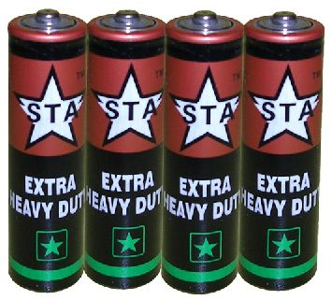 | 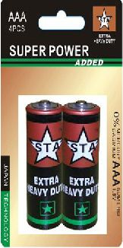 | 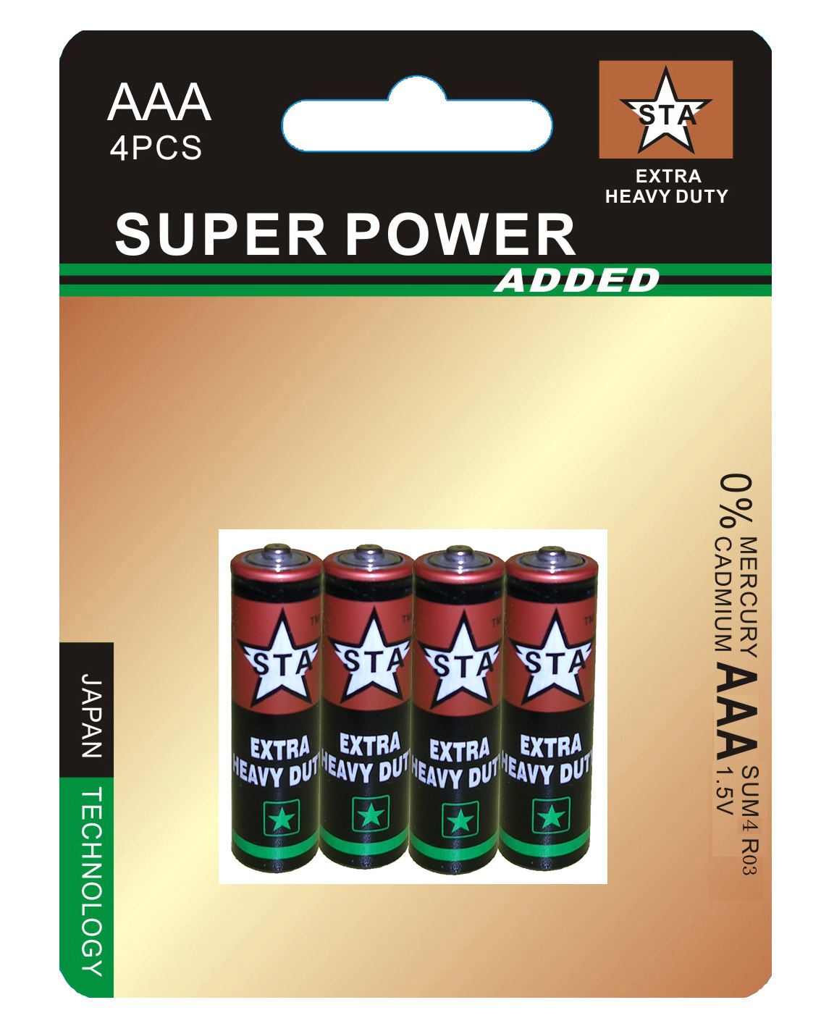
4pcs/shrink pack  200doz/ctn  G.W.:17KGS  Mea:0.0145CBM | 2pcs/card,  960 cards/ctn  G.W.:16.5KGS  Mea.:0.03735CBM | 4pcs/card,  288 cards/ctn  G.W.:7.5KGS  Mea.:0.02234CBM

